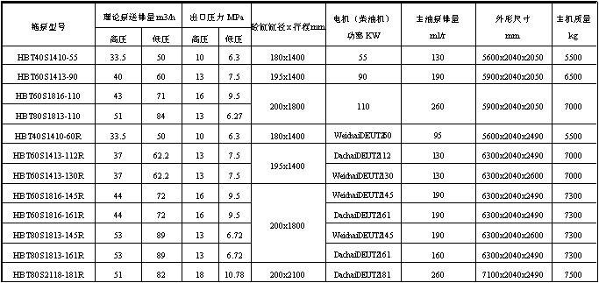
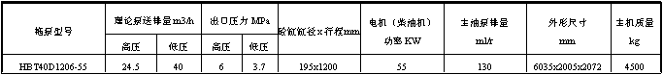
Main Technical Parameters of HBT-S-valve Series Trailer Concrete PUMP

Model | Pumping productivity in theory m3/h |  | Outlet pressure  MPa |  | Concrete cylinder dia meterXstroke  mm | Electric motor(diesel engine)Power  KW | Main oil pump displacement  ml/r | Outline dimension  mm | Main machine weight  kg
 | High pressure | Low pressure | High pressure | Low pressure
HBT40S1410-55 | 33.5 | 50 | 10 | 6.3 | 180x1400 | 55 | 130 | 5600x2040x2050 | 5500
HBT60S1413-90 | 40 | 60 | 13 | 7.5 | 195x1400 | 90 | 190 | 5900x2040x2050 | 6500
HBT60S1816-110 | 43 | 71 | 16 | 9.5 | 200x1800 | 110 | 260 | 5900x2040x2050 | 7000
HBT80S1813-110 | 51 | 84 | 13 | 6.27
HBT40S1410-60R | 33.5 | 50 | 10 | 6.3 | 180x1400 | WeichaiDEUTZ60 | 95 | 5600x2040x2490 | 5500
HBT60S1413-112R | 37 | 62.2 | 13 | 7.5 | 195x1400 | DachaiDEUTZ112 | 130 | 6300x2040x2490 | 7000
HBT60S1413-130R | 37 | 62.2 | 13 | 7.5 | 195x1400 | WeichaiDEUTZ130 | 130 | 6300x2040x2600 | 7000
HBT60S1816-145R | 44 | 72 | 16 | 9.5 | 200x1800 | WeichaiDEUTZ145 | 190 | 6300x2040x2490 | 7300
HBT60S1816-161R | 44 | 72 | 16 | 9.5 | 200x1800 | DachaiDEUTZ161 | 190 | 6300x2040x2490 | 7300
HBT80S1813-145R | 53 | 89 | 13 | 6.72 | 200x1800 | WeichaiDEUTZ145 | 190 | 6300x2040x2600 | 7300
HBT80S1813-161R | 53 | 89 | 13 | 6.72 | 200x1800 | DachaiDEUTZ161 | 160 | 6300x2040x2490 | 7300
HBT80S2118-181R | 51 | 82 | 18 | 10.78 | 200x2100 | DachaiDEUTZ181 | 260 | 7100x2040x2490 | 7500

Main Technical Parameters of HBT-Z-gate-valve Series Trailer Concrete PUMP

Model | Pumping productivity in theory (m3/h) | Outlet pressure  MPa | Concrete cylinder dia meterXstrokemm | Electric motor(diesel engine)Power  KW | Main oil pump displacement  ml/r | Outline dimension  mm | Main machine weight  kg
HBT60Z1407-75 | 69 | 7 | 200x1400 | 55 |  | 6370x2045x2050 | 5600
 |  |  |  | 75 | 190 | 6370x2045x2050 | 5600
HBT60Z1407-112R
 |  |  |  | DachaiDEUTZ112 | 130 | 6370x2045x2490 | 5600

Main Technical Parameters of HBT-D-butterfly-valve Series Trailer Concrete PUMP

Model | Pumping productivity in theory (m3/h) |  | Outlet pressure  MPa |  | Concrete cylinder dia meterXstrokemm | Electric motor(diesel engine)Power  KW | Main oil pump displacement  ml/r | Outline dimension  mm | Main machine weight  kg
Model | High pressure | Low pressure | High pressure | Low pressure
HBT40D1206-55 | 24.5 | 40 | 6 | 3.7 | 195x1200 | 55 | 130 | 6035x2005x2072 | 4500

